How to send Official Transcripts through GaFutures.org
- Sign in to your GaFutures Account.
- Click on “College Planning”
- Scroll down and click on “High School Transcripts”
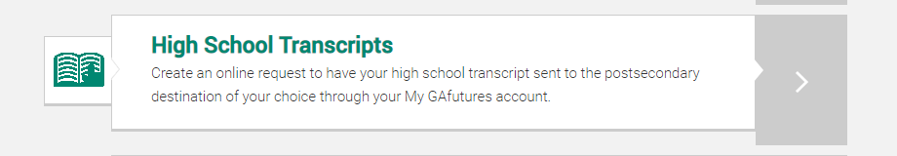
- Select the College you want your transcripts sent to.
- IMPORTANT – Your Social Security Number and Birthdate MUST be in your GaFutures Profile. If you do not see it displayed on this High School Transcripts page, enter it, and then go back to your Profile to make sure it’s there.
- Select Brookwood High School and your Graduation Year.
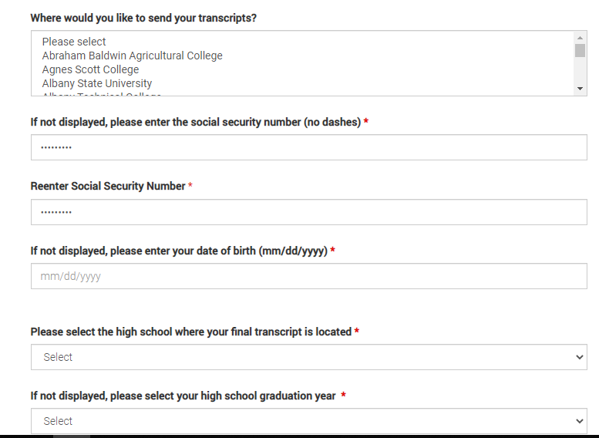
- Click “Acknowledge” and

